The Saginaw Charter Township Wastewater Treatment Plant purifies wastewater from the Southwest and Center Road Sewer Districts in Saginaw Township as well as from Thomas Township. Wastewater from Thomas Township is pumped to the site where it is metered and introduced to the treatment process. Wastewater from Saginaw Township arrives at the plant via gravity sewers. The wastewater is screened by mechanically cleaned screens and is lifted by the raw influent pumps where it is metered and merged with Thomas Township flows ahead of the grit screens then bleach is added for odor control. Screenings and grit removed from the wastewater is disposed of into dumpsters and hauled to a landfill.
The flows then pass through aerated grit tanks before it is split between the four primary clarifiers. The solids that are allowed to settle from the wastewater are pumped to two high rate anaerobic digesters. Secondary treatment consists of extended aeration with activated sludge in the two oxidation ditches. Ferric chloride is added to facilitate phosphorus removal and polymer is added to aid in the settling process in the three secondary clarifier tanks. The solids that are settled from the wastewater in these clarifiers is returned to the oxidation ditches, or wasted to the decant tanks, where additional settling occurs. This secondary sludge is pumped to the one million gallon above-ground, steel sludge storage tank.
The wastewater is then disinfected with chlorine gas and flows through the chlorine contact tank. The effluent is chemically dechlorinated as necessary and receives further polishing in the polishing pond. In times when the Tittabawassee River is high, the final effluent is pumped to the river, instead of flowing by gravity through the pond.
The sludge, or biosolids, are further treated in the concrete tanks where aeration, mixing and lime stabilization occurs prior to land application on agricultural fields.
There is an 800kW generator onsite to operate the plant in the event of a power outage. The design average day flow is 6.5 mgd and the peak hour design flow is 19.5 mgd.

SAGINAW CHARTER TOWNSHIP WASTEWATER TREATMENT PLANT
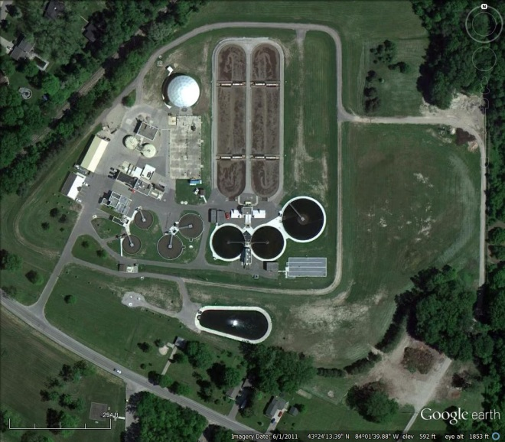

5790 W. Michigan, Saginaw
Phone (989) 793-1631
Fax (989) 793-8499

